**Assessments Specification**

**Document**

**User Interface Improvements**

**02-02-2022**

**Version 4**

**By: Jacob, Jared, Samantha and Simeon**

|  |
| --- |
| **Revisions** |

| Version | Primary Author(s) | Description of Version | Date Completed |
| --- | --- | --- | --- |
|  |  |  |  |

|  |
| --- |
| **Review & Approval** |

Requirements Document Approval History

| Approving Party | Version Approved | Signature | Date |
| --- | --- | --- | --- |
|  |  |  |  |
|  |  |  |  |

Requirements Document Review History

| Reviewer | Version Reviewed | Signature | Date |
| --- | --- | --- | --- |
|  |  |  |  |
|  |  |  |  |
|  |  |  |  |

|  |
| --- |
| **Table of Contents** |

1. Introduction 3

1.1 Purpose 3

1.2 Document Conventions…………………………………………………………………….3

1.3 Intended Audience…………………………………………………………………………3

1.4 Scope……………………………………………………………………………………….3

1.5 References………………………………………………………………………………….3

2. General Description 3

2.1 Product Perspective………………………………………………………………………...3

2.2 Product Features 3

2.3 User Class Characteristics 3

2.4 Operating Environment 3

2.5 Constraints 3

2.6 Assumptions and Dependencies 3

3. System Requirements 3

4. External Interface Requirements 4

4.1 User Interfaces 4

4.2 Hardware Interfaces 4

4.3 Communications Interfaces 4

4.4 Software Interfaces 4

5. Non Functional Requirements 4

1. Introduction

* 1. **Purpose:** The goal of the User Interface Development Team is to allow the Instructor to have a more streamlined and easier to use user interface and to allow the use of a multiclass report generation.
  2. **Document conventions:**
* UI – User Interface
* NCC – Nashua Community College
* CSV – Comma-Separated values or an Excel Spreadsheet

* 1. **Intended audience:** The Stakeholders and Nashua Community College Faculty.
  2. **Scope:** The Software Goals align with the Business Goals to help overall productivity and to allow a more streamlined user experience.With this polished version of the UI, this will greatly impact the productivity of the instructors by allowing multiple comparisons at a time.
  3. **References:** N/A

## 2. General Description

**2.1 Product perspective:** To improve the User Interface experience from the last User Interface Development team.

* 1. **Product features:**
* To allow the instructor to select from a list of available courses
* To allow the selection of One or More available courses by a given instructor
* To allow the selection of all sections of a course
* To allow the selection of all courses in each semester
* To allow the instructor to Clear their selections once chosen
* To allow the instructor to find the generated spreadsheet more easily
  1. **User class and characteristics:** Permitted for use by the NCC staff only.
  2. **Operating environment:** Designed to work with the Windows 10 environment and later.
  3. **Constraints:**
* The user is not using a Windows machine
* Time not allowing for all the demands to be met
* Project deadlines not being met by other teams
* Certain data might not be retrievable from Canvas
  1. **Assumptions and dependencies:**
* We are assuming that the original code from the previous team still works
* We are assuming that the User has previous knowledge of how to work with a Windows machine and how to access its file system

## 3. System Requirements

**3.1 Functional requirements**

All the requirements within the system or in order to determine the output that the software is expected to give in relation to the given input. These consist of the design requirements, graphics requirements, operating system requirements and constraints if any. User interface requirements. Input the token key to get the courses available to the user.

Once the token key has been inputted, the available courses will be accurately outputted to the user. These courses can be displayed through what they are currently teaching or can be broadly displayed as all the courses throughout the user’s available semester file.

## 4.External Interface Requirements

4.1 User Interfaces

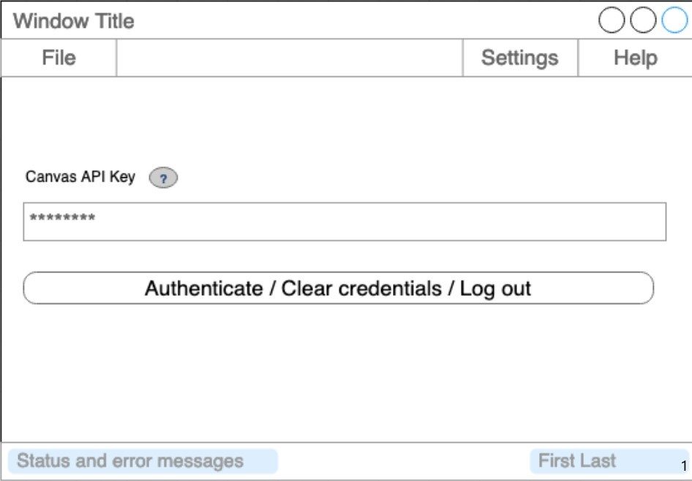

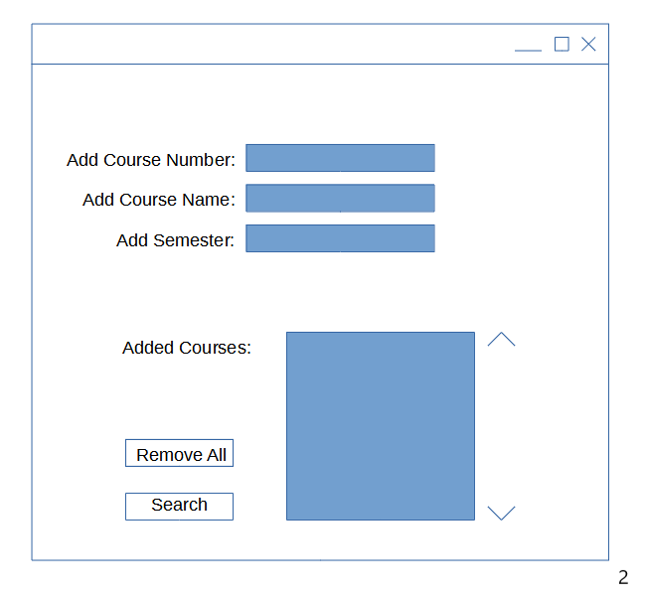

4.2 Hardware Interfaces

A Windows 10 or later computer will be needed with an internet connection.

4.3 Communications Interfaces

The English Language and The C++ Programming Language.

4.4 Software Interfaces

The software will retrieve the course numbers and user key from the user interface improvements group to be used to retrieve outcome data from Canvas. The csv files will be sent to the visualizations group for a visual comparison.

## 5. Non-Functional Requirements

**5.1 Performance requirements**

Only a Windows capable machine and an internet are required.

**5.2 Safety requirements**

N/A

**5.3 Security requirements**

Do not allow the user’s authorization code to be used by anyone that is not intended to use that code.

**5.4 Software quality attributes**

The code will be kept clean and with plenty of comments so that teams even many years down the line will be able to read it and understand what that specific chunk of code does.

**5.5 Other requirements**

No other requirements at this moment in time.